CHAPTER THREE: RESEARCH METHODOLOGY

3.1 Introduction
The research methodology for the "Sales Forecasting Model for Inventory and Budget Planning" system follows a structured data-driven approach. The study aims to move beyond reactive inventory management by employing predictive analytics. We focus on two primary machine learning techniques: Linear Regression for trend analysis and SARIMA (Seasonal Autoregressive Integrated Moving Average) for capturing complex seasonal patterns. The methodology ensures that forecasts directly inform inventory replenishment and budget allocation.

3.2 Analysis of the Existing System
Traditional inventory systems often rely on manual entry, simple spreadsheets, or "gut feeling" to determine stock levels.

Limitations of the Existing System
• Lack of Foresight: Decisions are based on past stockouts rather than future demand, leading to lost sales or overstocking.
• Manual Error: Spreadsheets are prone to human error and difficult to scale as product catalogs grow.
• Static Budgeting: Budgets are often fixed and do not adjust to real-time sales performance or seasonal spikes.
• Data Silos: Inventory, sales, and budget data are often disconnected, preventing a holistic view of financial health.

3.3 Overview of the Proposed System
The proposed system is an integrated Sales Forecasting Dashboard that uses time-series analysis to predict demand and automate inventory/budget tracking.

3.3.1 Objectives of the Proposed System
• To provide proactive demand forecasting using multiple ML models.
• To automate inventory decrementing upon successful sale recording.
• To monitor budget utilization in real-time against sales revenue and cost targets.
• To offer a visual interface for comparing model performance (Linear vs. SARIMA).

3.3.2 Benefits of the Proposed System
• Reduced Overstocking and Stockouts: By accurately predicting demand, the system ensures that capital is not tied up in excess inventory and that sales opportunities are not lost due to empty shelves.
• Data-Driven Financial Planning: Real-time budget monitoring allows for agile financial adjustments, moving away from static, unresponsive budgeting cycles.
• Operational Efficiency: Automating the link between sales records and inventory levels reduces manual entry errors and frees up staff for strategic tasks.
• Improved Accuracy: The combination of Linear Regression and SARIMA models provides a comprehensive view of both general trends and complex seasonal fluctuations, leading to more reliable forecasts.

3.4 System Architecture and Design
The system follows a modular architecture consisting of data handling, feature extraction, model inference, and result presentation.

3.4.1 Architectural Design of the System
The following diagram illustrates the flow from the user interface through the FastAPI backend to the machine learning models and database.
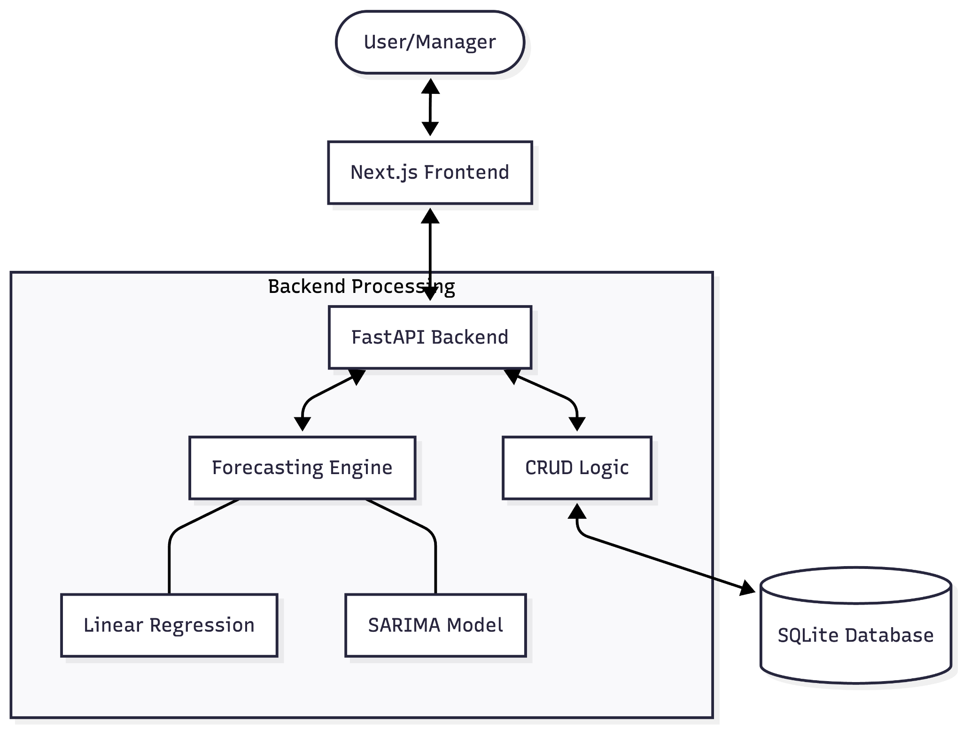
Figure 3.1: System Architecture Diagram

3.4.2 Use Case Diagram
The system supports two primary roles: the Sales Manager and the Inventory Planner.
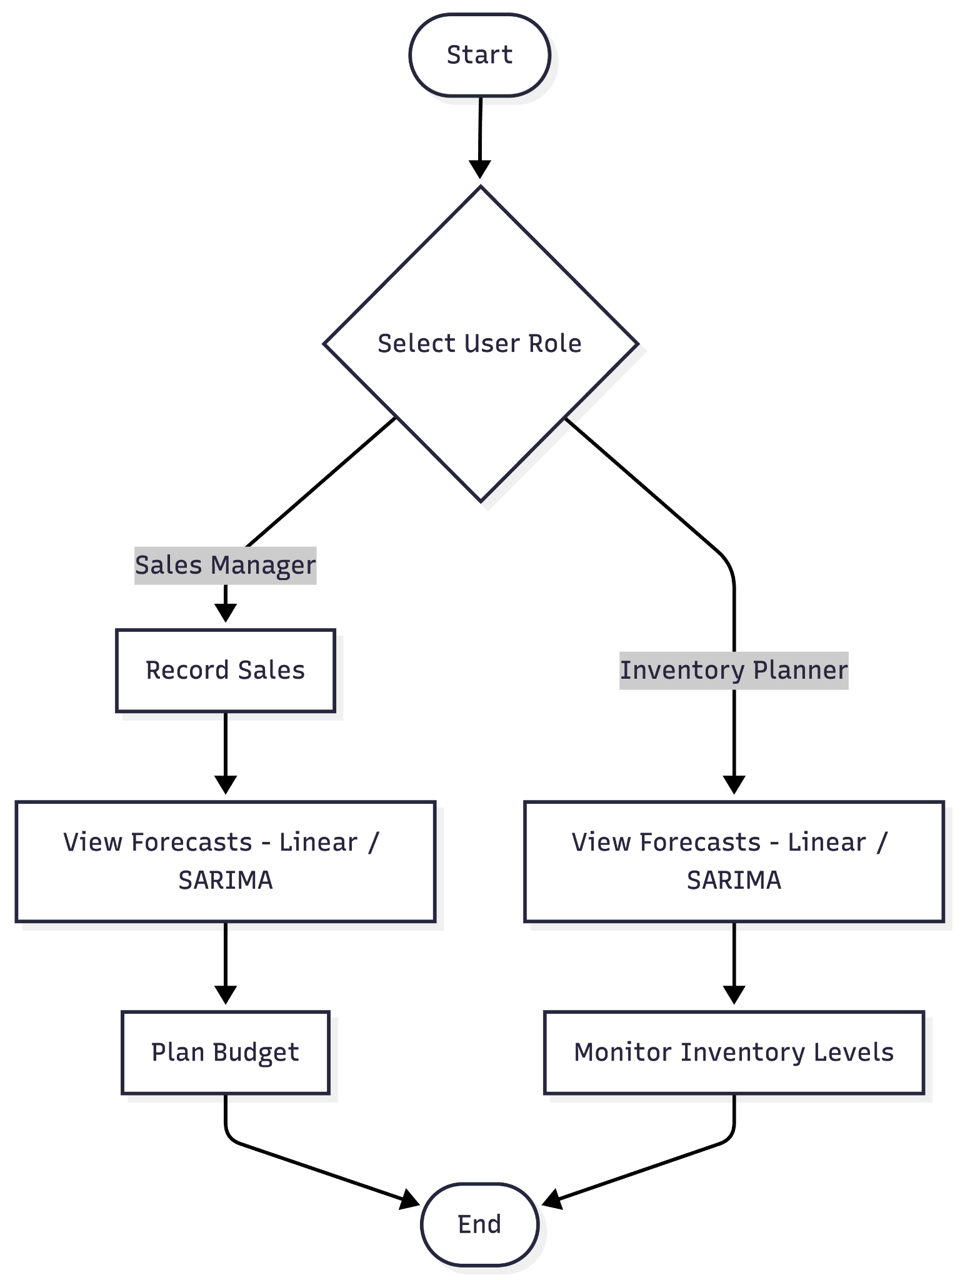
Figure 3.2: Use Case Diagram

3.4.3 Functional Requirements
The functional requirements define the core actions the system must perform to meet user needs:
• Sales Management: The system shall record sales transactions, automatically calculate total amounts, and decrement stock levels.
• Inventory Tracking: The system shall maintain real-time stock levels and highlight products requiring replenishment.
• Demand Forecasting: The system shall generate 7-day and 30-day demand forecasts using Linear Regression and SARIMA models.
• Budget Monitoring: The system shall track actual revenue/costs against predefined period-based budgets and alert users of variances.
• Data Visualization: The system shall provide interactive charts for comparing model performance and visualizing sales trends.

3.4.4 Non-Functional Requirements
These requirements define the system's quality attributes:
• Performance: ML forecast generation (SARIMA) should complete within 1 second for a typical product history.
• Accuracy: The system aims for a Root Mean Square Error (RMSE) below 10 for seasonal products.
• Scalability: The backend (FastAPI) should handle concurrent requests from multiple sales managers.
• Usability: The dashboard must be responsive and accessible across standard web browsers (Chrome, Firefox, Safari).

3.4.5 Data Dictionary
The following tables describe the database schema used in the system.
Table 3.1: Product Entity
Field | Type | Description
id | Integer (PK) | Unique identifier for the product.
name | String | Commercial name of the product.
category | String | Classification (e.g., Electronics, Food).
cost_price | Float | Internal purchasing cost.
selling_price | Float | Customer-facing price.
stock_quantity | Integer | Current units available in warehouse.
Table 3.2: Sale Entity
Field | Type | Description
id | Integer (PK) | Unique identifier for the sale record.
product_id | Integer (FK) | Reference to the Product sold.
quantity | Integer | Number of units sold.
total_amount | Float | Calculated revenue (selling_price * quantity).
sale_date | DateTime | Timestamp of the transaction.

Table 3.3: Budget Entity
Field | Type | Description
id | Integer (PK) | Unique identifier for the budget.
category | String | The category this budget applies to.
amount_limit | Float | The financial target or ceiling.
period_start | DateTime | Beginning of the budget cycle.
period_end | DateTime | End of the budget cycle.
current_spend | Float | Cumulative revenue/cost tracked in the period.

3.4.6 Entity Relationship Diagram (ERD)
The relationship between products, their sales, and the category-based budgets is illustrated below:
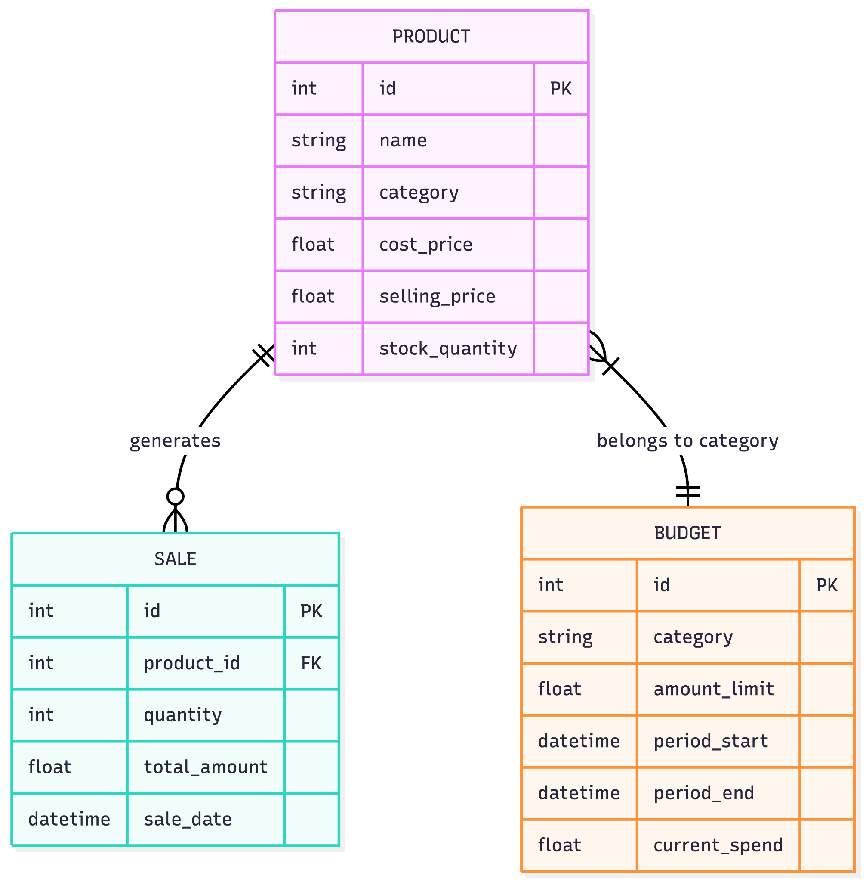

Figure 3.3: Entity Relationship Diagram

3.4.7 System Flowchart
The following flowchart demonstrates the internal logic when a sale is recorded, triggering inventory updates and budget tracking.
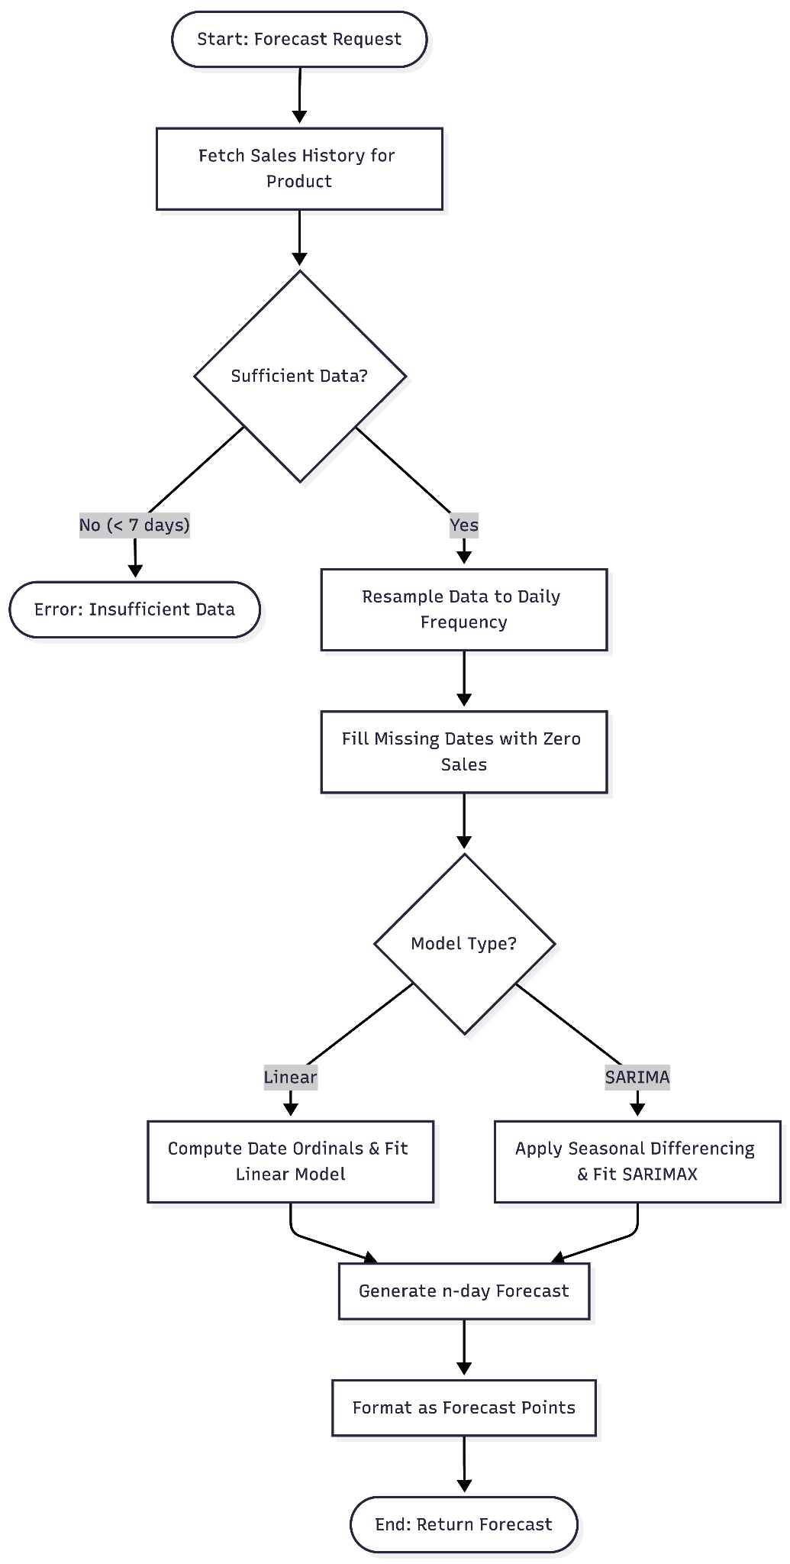
Figure 3.4: Sales Processing Flowchart

3.4.8 System Framework
The proposed system is built on a Modular Layered Framework that separates concerns between the user interface, application logic, and data storage.
• Presentation Layer (Frontend): Built with Next.js, this layer handles user interaction and data visualization using Recharts. It communicates with the backend via RESTful API calls.
• Service Layer (Backend): Utilizes FastAPI to manage business logic, including sales processing and budget tracking. It acts as the orchestrator between the user requests and the analytical engines.
• Analytical Layer (ML Engine): A dedicated module responsible for data resampling, preprocessing, and model inference (Linear Regression and SARIMA).
• Data Layer (Storage): Employs SQLAlchemy as an ORM to interact with an SQLite database, ensuring data persistence and integrity.

3.4.9 Forecasting Logic Flowchart
The following flowchart details the internal operations performed when the system generates a demand forecast.

Figure 3.5: Forecasting Engine Logic Flowchart

3.5 Machine Learning Algorithms Used
Two key algorithms are implemented to handle different aspects of sales data behavior.

3.5.1 Linear Regression
A fundamental algorithm that models the relationship between time (date ordinal) and quantity sold.
• Justification: Excellent for identifying long-term growth trends and providing a stable baseline. It is extremely fast to compute and interpret.

3.5.2 SARIMA (Seasonal ARIMA)
A sophisticated time-series model that accounts for trend, noise, and seasonality.
• Justification: Essential for capturing cyclic patterns (e.g., higher sales every Friday or monthly spikes). It differences the data to handle non-stationarity, making it far more accurate for sales forecasting than standard regression.

3.6 Dataset Description
The system is designed to work with transactional sales data.
• Product Data: Name, Category, Cost Price, Selling Price, and current Stock Quantity.
• Sales History: Product ID, Quantity sold, Total amount, and precise Timestamp.
• Budget Info: Category-based allocation, Amount limits, and period durations.

3.7 Data Preprocessing and Model Training
• Resampling: Sales data is aggregated daily to ensure a continuous time series for the SARIMA model.
• Date Transformation: Dates are converted into numerical ordinals for the Linear Regression engine.
• Handling Nulls: Missing days in sales are filled with zero-sale placeholders to maintain frequency consistency.
• Model Switching: The system allows dynamic parameters (e.g., 7-day or 30-day horizons) to be passed via API.

3.8 Implementation Tools
• Backend: Python (FastAPI), SQLAlchemy (Database abstraction).
• Machine Learning: Scikit-learn (Linear Regression), Statsmodels (SARIMAX), Pandas (Data processing).
• Frontend: Next.js (React), Tailwind CSS (Styling), Recharts (Data Visualization).

